**Redox Reactions under Acidic Conditions**

To write half equations for redox reactions occurring under acidic conditions, the following steps are taken:



[How to Balance Acidic Redox](https://www.youtube.com/watch?v=IZ1tKxsqV74)

[Balancing Acidic Redox (Advanced)](https://www.youtube.com/watch?v=i9s9Qv4EcI0)

**Example: the reduction of NO3 to N2O under acidic conditions**

1. Balance all elements except hydrogen and oxygen in the half-equation.

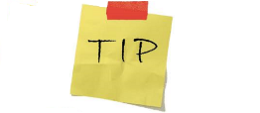 2NO3− → N2O

Leave a space between the first reagent on the left and the arrow this allows you to add any extra reagents

1. Balance the oxygen atoms by adding water molecules.

2NO3− → N2O + 5H2O

1. Balance the hydrogen atoms by adding H+ ions.

2NO3− + 10H+ → N2O + 5H2O

1. Balance the charge in the equation.

2NO3− + 10H+ + 8e− → N2O + 5H2O

To balance the charge, add electrons. In this case the total charge on the left-hand side is (2×−1) + (10×+1) = +8. The total charge on the right-hand side is 0. To make the charges equal add 8electrons to the left-hand side.

1. Add states to complete the half-equation.

2NO3−(aq) + 10H+(aq) + 8e− → N2O(g)+5H2O(l)

The above steps are repeated for the other half equation

**Oxidation of Organic Molecules under Acidic Conditions**

There are many ways to show the oxidation of an organic compound. One method is to simply show the resulting organic product and add the oxidizing agent above the arrow.

For example: the oxidation of propanal to propanic acid using acidified dichromate can be written as:

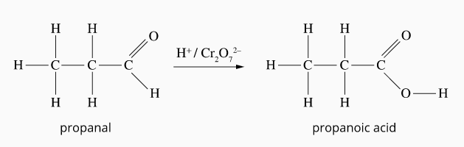

However you may be asked to write half equations, or even a full redox equation. The method outlined above will need to be used for to determine each half equation. The redox equation is produced by adding the two half equations together in the usual method.

**Oxidation of a Primary Alcohol**

Write oxidation and reduction half equations and a redox equation for the oxidation of ethanol using acidified potassium dichromate, K2Cr2O7.

**Oxidation half equation (ethanol to ethanoic acid)**

**NB:** This equation shows the “full” oxidation of this primary alcohol to a carboxylic acid. You could also write an equation for the “partial” oxidation of the alcohol to the aldehyde (ethanal).

Balance all elements except hydrogen and oxygen in the half-equation.

C2H5OH 🡪 CH3COOH (already balanced)

Balance the oxygen atoms by adding water molecules.

**C2**H5OH + H2O 🡪 CH3COOH

Balance the hydrogen atoms by adding H+ ions

**C2**H5OH + H2O 🡪 CH3COOH + 4H+

Balance the charge in the equation.

**C2**H5OH + H2O 🡪 CH3COOH + 4H+ +4e-

Add states to complete the half-equation.

**C2**H5OH(aq) + H2O(l) 🡪 CH3COOH(aq) + 4H+(aq) + 4e-

**Reduction half equation (dichromate to chromium)**

Cr2O72- 🡪 2Cr3+ (step 1)

Cr2O72- 🡪 2Cr3+ +7H2O (step 2)

Cr2O72- + 14H+ 🡪 2Cr3+ +7H2O (step 3)

Cr2O7−2 + 14H+ + 6e- 🡪 2Cr3+ +7H2O (step 4)

Cr2O72-(aq) + 14H+(aq) +6e- 🡪 2Cr3+(aq)+7H2O(l) (step 5)

If the redox equation is required, add half equations together in the usual way.

3C2H5OH(aq) +3H2O(l) + 2Cr2O72−(aq)+ 28H+(aq) +12e- → 3CH3COOH(aq) + 12H+ + 4Cr3+(aq) + 14H2O(l) +12e-

Then Simplify

3C2H5OH(aq) + 2Cr2O72−(aq)+ 16H+(aq) → 3CH3COOH(aq) + 4Cr3+(aq) + 11H2O(l)

TIPS:

* The potassium ion in the potassium dichromate ion is a spectator and therefore not included.
* The equation for the reduction of dichromate is included on the data sheet so you do not usually have to go through the above process
* Don’t’ forget to “simply” your redox equation.

**Oxidation of a Secondary Alcohol**

Write oxidation and reduction half equations and a redox equation for the oxidation of propan-2-ol using acidified potassium permanganate, KMnO4.

**Oxidation half equation (propan-2-ol to propanone)**

Balance all elements except hydrogen and oxygen in the half-equation.

C3H7OH 🡪 C3H6O (already balanced)

Balance the oxygen atoms by adding water molecules.

C3H7OH 🡪 C3H6O (already balanced)

Balance the hydrogen atoms by adding H+ ions

C3H7OH 🡪 C3H6O + 2H+

Balance the charge in the equation.

C3H7OH 🡪 C3H6O + 2H+ + 2e-

Add states to complete the half-equation.

C3H7OH (aq) 🡪 C3H6O (aq) + 2H+ (aq)+ 2e-

**Reduction half equation (permanganate to manganese)**

MnO4- 🡪 Mn2+ (step 1)

MnO4- 🡪 Mn2+ + 4H2O (step 2)

MnO4- + 8H+ 🡪 Mn2+ + 4H2O (step 3)

MnO4- + 8H+ + 5e- 🡪 Mn2+ + 4H2O (step 4)

MnO4-(aq) + 8H+(aq) + 5e- 🡪 Mn2+ (aq)+ 4H2O (Step 5)

If the redox equation is required, add half equations together in the usual way.

5C3H7OH (aq) + 2MnO4-(aq) + 16H+(aq) + 10e- 🡪 5C3H6O (aq) + 10H+ + 2Mn2+(aq) + 8H2O +10e-

The Simplify

5C3H7OH (aq) + 2MnO4-(aq) + 6H+(aq) 🡪 5C3H6O (aq) + 2Mn2+(aq) + 8H2O

TIPS:

* The potassium ion in the potassium permanganate ion is a spectator and therefore not included.
* The equation for the reduction of permanganate is included on the data sheet so you do not usually have to go through the above process
* Don’t’ forget to “simply” your redox equation.

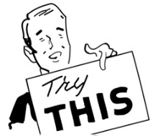

Write oxidation and reduction half equations and a redox equation for the oxidation of the aldehyde proponal, using acidified potassium dichromate, K2Cr2O7.